**HIV Supply Chain System**

User Manual



Technology developed by: 

**REVISION HISTORY**

|  |  |  |  |
| --- | --- | --- | --- |
| **Version** | **Date** | **Description** | **Author** |
| V 1.0 | 07 – Aug – 2013 | Created | Mr. An Yon |
| V 1.0 | 01 – Sept – 2013 | Reviewer | Mr. Rum Sokha |

**TABLE OF CONTENT**

I- HIV Supply Chain System Functionalities 1

II- HIV Supply Chain System 2

III- HIV Supply Chain System Setting 3

A- System User Setting 3

1- Add New System User 3

2- Edit System User 5

3- Reset User Password 5

4- Delete System User 6

B- Site Setting 7

1- Add New Site to the System 7

2- Edit Site in the System 10

3- Delete Site in the System 10

C- Parameter Setting 10

D- Commodity Setting 13

1- Add New Drug commodities to the System 13

2- Edit Drug Commodity in the System 14

3- Delete Drug Commodity in the System 15

4- Add New Kit commodities to the System 15

5- Edit Kit commodities in the System 16

6- Delete Kit commodities from the System 17

E- Public Holiday Setting 17

1- Add Public Holiday to the System 17

2- Edit Public Holiday in the System 18

3- Delete Public Holiday from the System 19

F- View SMS Logs 19

VII- Site User in HIV Supply Chain System 20

A- Download Requisition Report Template 20

B- Fill in Requisition Report to order commodities 21

C- Upload Requisition Report to order the commodities 22

VIII- Data Entry User in HIV Supply Chain System 24

A- Entering SURV form data 24

B- Edit Data in SURV form 25

C- Delete SURV form’s data 25

D- Make Requisition Order 26

E- Edit Requisition Order 27

IX- Reviewer User in HIV Supply Chain System 27

X- AMS User in HIV Supply Chain System 30

A- Create New Shipment 30

B- Updating Shipment Status 32

XI- SMS Confirm from the Site 33

# **I- HIV Supply Chain System Functionalities**

1. Setting
   * User Setting
   * Site Setting
   * Parameter Setting
   * Commodity Setting
   * Public Holiday Setting
2. Site
   * Download Requisition Template
   * Update Requisition Template
3. Date Entry
   * Surv From (SURV1 & SURV2)
   * Order
4. Reviewer
   * Agree or Refuse the order
5. AMS
   * Create Consignment (Shipment)
6. SMS
   * Alert to site if they forget sending requisition form
   * Send SMS to site when there is shipment to that site
   * Alert to site if they already received the shipment

# **II- HIV Supply Chain System**

A user account is required to access the system. You can contact the system administrator for obtaining a login account.

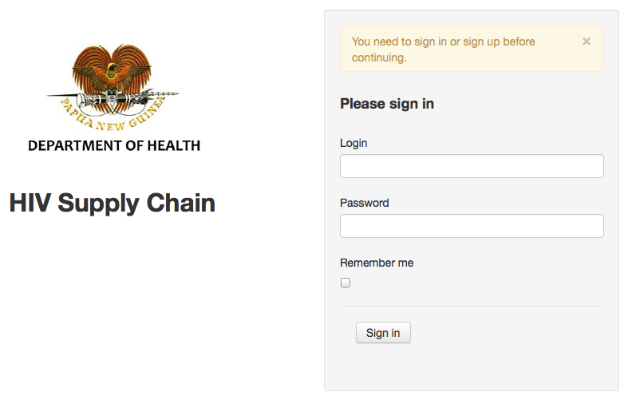

# **III- HIV Supply Chain System Setting**

In order to start using HIV Supply Chain System, system administrator has to set the system setting first.

## A- System User Setting

In HIV Supply Chain System, there are 5 different levels of users: system administrator, site user, data entry user, reviewer user, and shipment user. Only the system administrator who has right to create these users.

### 1- Add New System User

1- Log in as administrator

2- Click menu **“Users”**

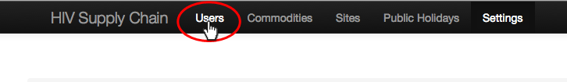

3- Click button **“New User”**

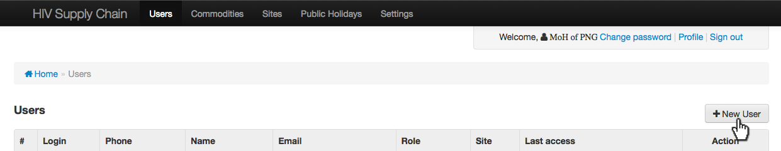

4- Fill in the require information below:

- **User name:** fill in the name for login to the system.

- **Password:** fill in the password for login to the system.

- **Password confirmation:** refill the password again.

- **Phone number:** fill in the phone number of user.

- **Email:** fill in the email of user.

- **Display name:** fill in the display name.

- **Role:** click on drop down box and choose the role for the user.

- Choose **“Admin”** if you want to create a system administrator.

- Choose **“Date Entry”** if you want to create a user as data entry.

- Choose **“Reviewer”** if you want to create a reviewer.

- Choose **“AMS”** if you want to create a shipment user.

- Choose **“Site”** if you want to create a site user.

In case of the user role is site level, you have to select the site for this user by clicking on site’s drop down box and choose the site.

- **Site:** click on drop down box and choose the site if the role of user is site level.

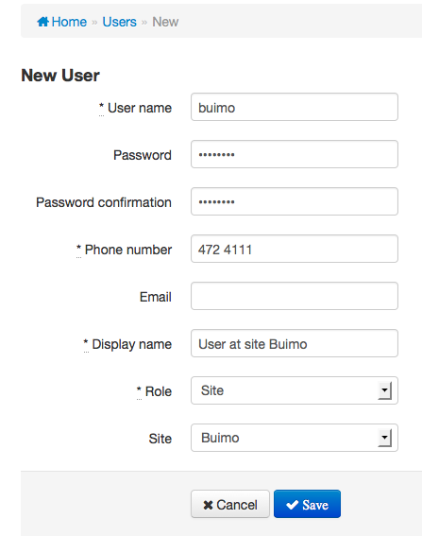

*This screenshot show that the user “buimo” is the site user of site “Buimo”*

5- Click button **“Save”**

### 2- Edit System User

1- Log in to the system as administrator

2- Click menu **“Users”**

3- Click on button **“Edit”** of the user that you want to edit

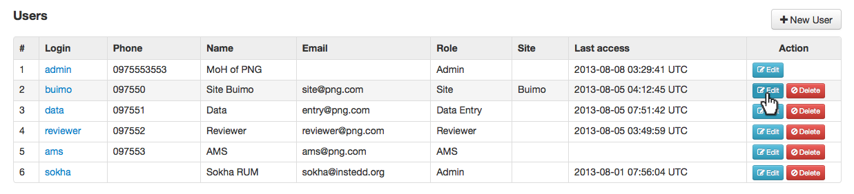

*This screenshot show that we want to edit user “buimo”*

4- Edit the user as you want then click button **“Save”**

### 3- Reset User Password

1- Log in to the system as administrator

2- Click menu **“Users”**

3- Click on button **“Edit”** of the user that you want to edit



*This screenshot show that we want to edit user “buimo”*

4- Click button **“Reset password”**

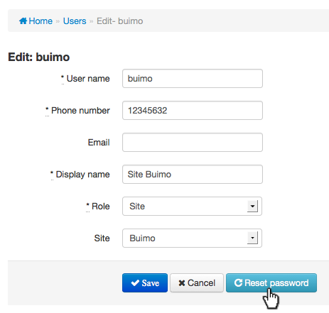

5- Click button **“OK”** to confirm of changing password. The system will automatically generate new password for that user.

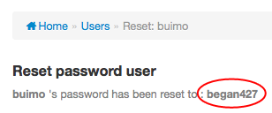

*This screenshot shows that the new password for user “Buimo” is “began427”*

### 4- Delete System User

1- Log in to the system as administrator

2- Click menu **“Users”**

3- Click on button **“Delete”** of the user that you want to delete

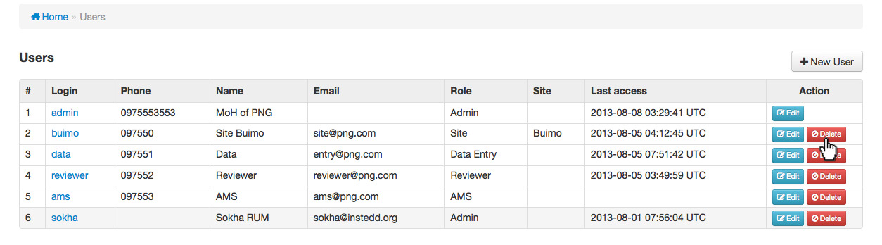

*This screenshot show that we want to delete user “buimo”*

4- Click button **“OK”** to confirm deleting

## B- Site Setting

In HIV Supply Chain, the administrator can add new site, edit or delete site.

### 1- Add New Site to the System

1- Log in to the system as administrator

2- Click menu **“Sites”**

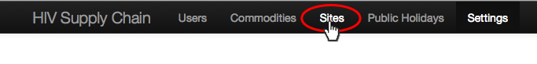

3- Click on button **“New Site”**

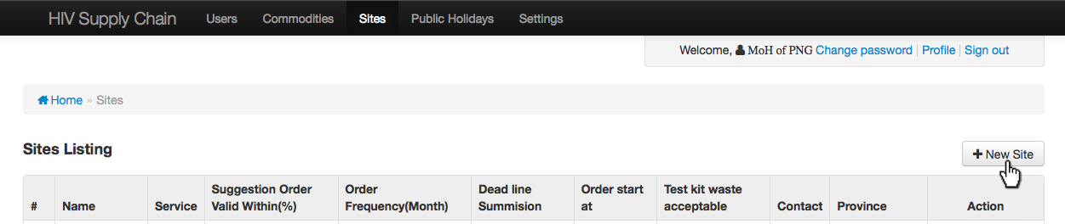

4- Fill in the required information as below:

* + - * **Name:** fill in the name of site you’re going to create.
      * **Latitude:** fill in the latitude location of site you’re going to create.
      * **Longitude:** fill in the longitude location of site you’re going to create.
      * **Service Type:** choose “ART”, “PMTCT” or “VCCT” service from the drop donw box.
      * **Suggestion Order Valid Within (%):** fill in the maximum percentage of difference between system suggestion and system calculation
      * **Every:** fill in the duration of the site should be received message if this site does not confirm package received.
      * **Duration type:** choose “Hour” or “Day”. It associates with the number you fill in “Every” field above.
      * **Order Frequency (Month):** fill in the interval in months between 2 orders.
      * **Number of deadline submission:** fill in the number of days to alert if the site hasn’t not yet sent the order.
      * **Order Start Month:** choose the month to start order for this site.
      * **Acceptable wastage % test kit:** fill in the wastage percentage that this site can accept.
      * **Address:** fill in the address of site.
      * **Contact name:** fill in the contact name for this site.
      * **Mobile:** fill in the phone number of the site.
      * **Land line number:** fill in the land line number of the site.
      * **Email:** fill in the email of that site.
      * **Province:** click drop down box and choose the province where site is located.

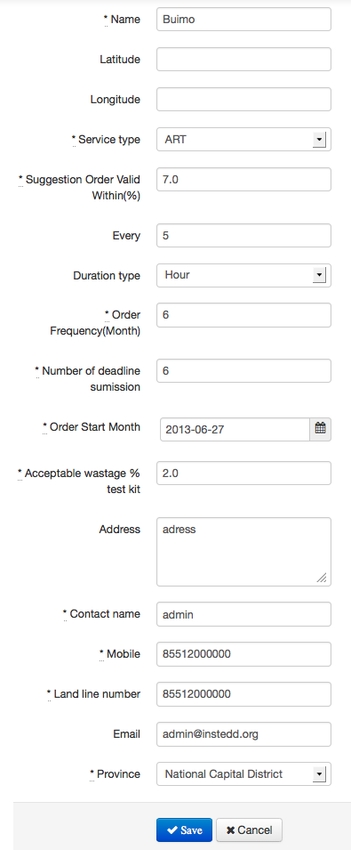

5- Click button **“Save”**

### 2- Edit Site in the System

1- Log in to the system as administrator

2- Click menu **“Sites”**

3- Click on button **“Edit”** of the site that you want to edit

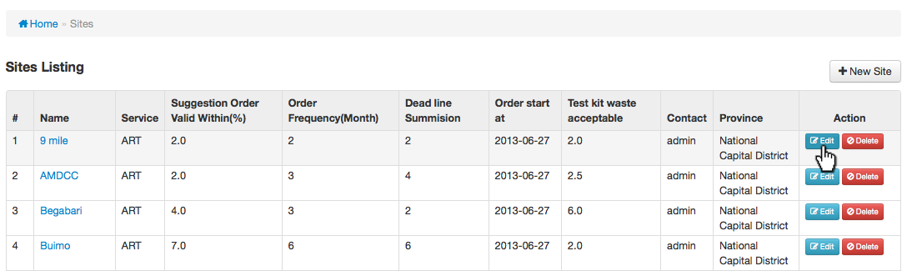

4- Edit the site information as you want then click button **“Save”**

### 3- Delete Site in the System

1- Log in to the system as administrator

2- Click menu **“Sites”**

3- Click on button **“Delete”** of the site that you want to delete

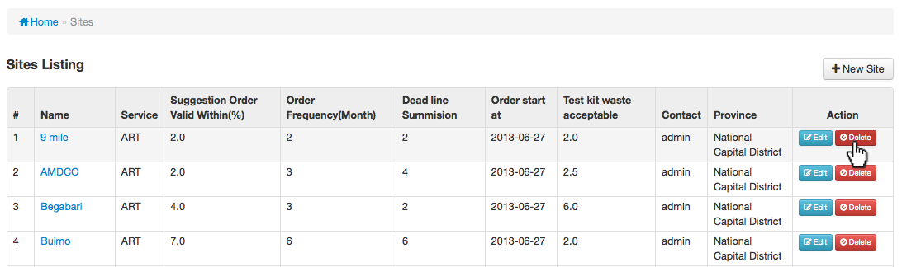

4- Click button **“OK”** to confirm deleting site

## C- Parameter Setting

In HIV Supply Chain, normally there are messages alert to the people at site when the package has been delivered, message to confirm of receiving package from the site and message to remind the site who did not yet submit the requisition form.

1- Log in to the system as administrator

2- Click menu **“Settings”** and set the message as below:

* + - Choose **“Hours”** or **“Days”** for reminding to the site who did not confirm package received and type the number.



*This screenshot show that the message will be sent from system every 4 hours if the site does not confirm package received.*

* + - Message notification of delivering package to site
    - Message check for confirmation of receiving package to site
    - Message reminder to site who hasn’t not submitted requisition form by deadline
    - Acknowledgment message: message has been sent to system successfully
    - Acknowledgment message: message syntax error
    - Acknowledgment message: consignment number is invalid
    - Acknowledgment message: status is invalid
    - Acknowledgment message: invalid carton format
    - Acknowledgment message: phone number is not allowed to report

3- Click button **“Save”** to save the parameter setting

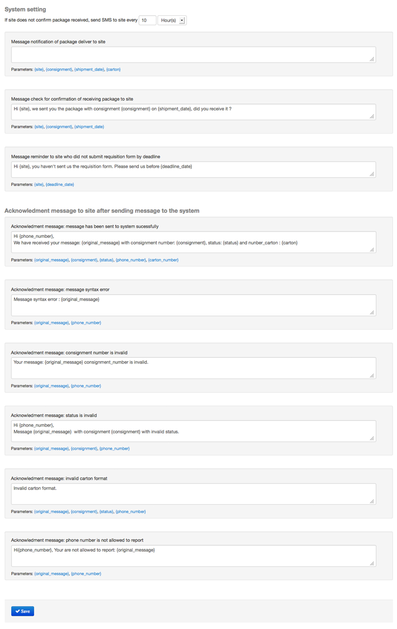

## D- Commodity Setting

There are two different kinds of commodity in HIV Supply Chain System. Those are “Drug” and “Kit”

### 1- Add New Drug commodities to the System

1- Log in to the system as administrator

2- Click menu **“Commodities”**

3- Click tab **“Drug”**

4- Click button **“New Drug”**

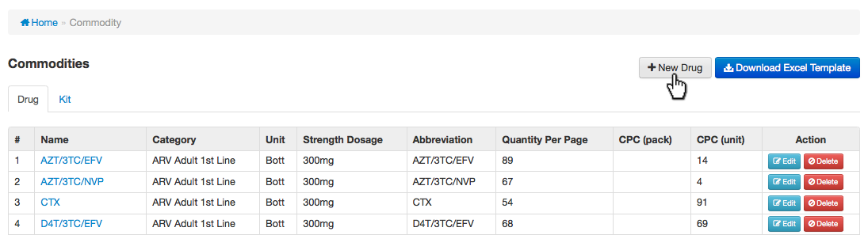

5- Fill in the information for new drug as below:

* + - **Name:** fill in the name of drug
    - **Commodity category:** choose the drug category from the drop down list by click on drop down box
    - **Consumption per client per month (pack):** fill in the average number of the package used per month for one client
    - **Consumption per client per month (unit):** fill in the average number of the unit used per month for one client
    - **Unit:** click on drop down box and choose the unit for the drug
    - **Strength/Dosage:** fill in the doss or strength of the drug
    - **Abbreviation:** fill in the sort name of the drug
    - **Quantity per Package:** fill in the number of drugs per package.

6- Click button **“Save”**

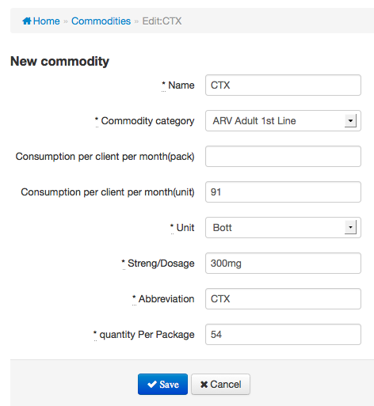

### 

### 2- Edit Drug Commodity in the System

1- Log in to the system as administrator

2- Click menu **“Commodities”**

3- Click tab **“Drug”**

4- Click button **“Edit”** of the drug commodity that you want to edit

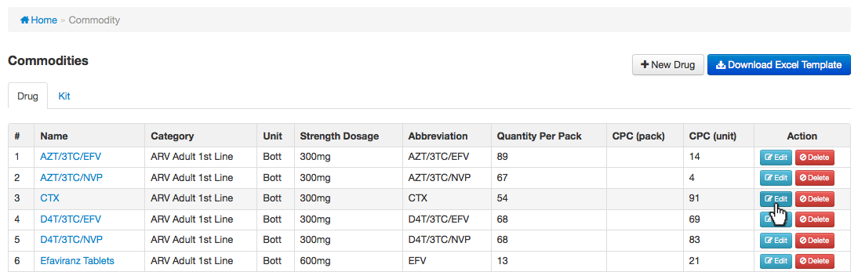

*This screenshot show that we want to edit “CTX” drug commodity*

5- Edit the drug commodity as you want to click button **“Save”**

### 3- Delete Drug Commodity in the System

1- Log in to the system as administrator

2- Click menu **“Commodities”**

3- Click tab **“Drug”**

4- Click button **“Delete”** of the drug commodity that you want to delete

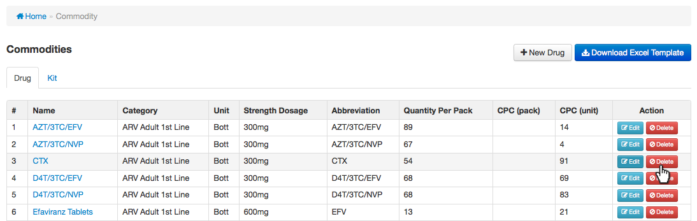

*This screenshot show that we want to delete “CTX” drug commodity*

5- Click button **“OK”** to confirm delete

### 4- Add New Kit commodities to the System

1- Log in to the system as administrator

2- Click menu **“Commodities”**

3- Click tab **“Kit”**

4- Click button **“New Kit”**

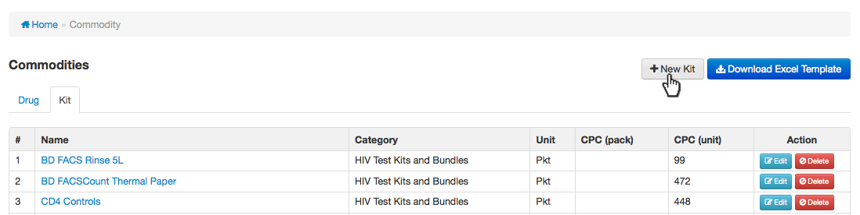

5- Fill in the information for new kit as below:

* + - **Name:** fill in the name of kit
    - **Commodity category:** choose the kit category from the drop down list by clicking on drop down box
    - **Consumption per client per month (pack):** fill in the average number of the pack used per month for one client
    - **Consumption per client per month (unit):** fill in the average number of the unit used per month for one client
    - **Unit:** click on drop down box and choose the unit for the kit

6- Click button **“Save”**

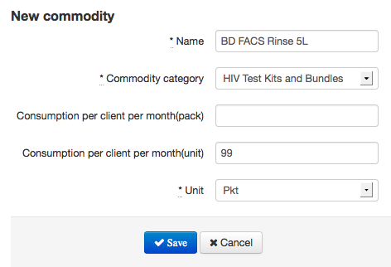

*This screenshot show that the new kit “BD FACS Rinse 5L” will be created*

### 5- Edit Kit commodities in the System

1- Log in to the system as administrator

2- Click menu **“Commodities”**

3- Click tab **“Kit”**

4- Click button **“Edit”** of the kit that you want to edit

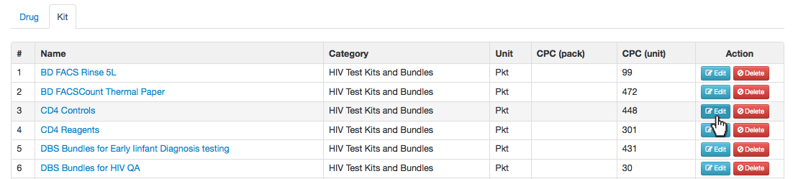

5- Edit the kit as you want then click button **“Save”**

### 6- Delete Kit commodities from the System

1- Log in to the system as administrator

2- Click menu **“Commodities”**

3- Click tab **“Kit”**

4- Click button **“Delete”** of the kit that you want to delete

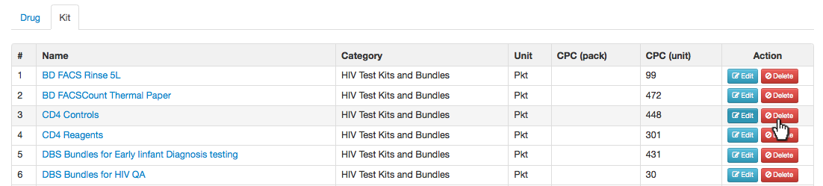

5- Click button **“OK”**

## E- Public Holiday Setting

In HIV Supply Chain System, public holiday is used to determine the day when the system sends SMS to site. Because the system does not send SMS in week-end nor on public holiday.

### 1- Add Public Holiday to the System

1- Log in to the system as administrator

2- Click menu **“Public Holidays”**

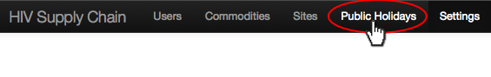

3- Click button **“New Public Holiday”**

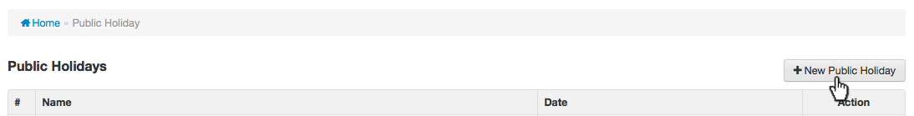

4- Fill in the informaiton for public holiday as below:

* + - **Name:** fill in the name of holiday
    - **Date:** set the date of public holiday

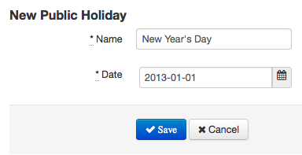

*This screenshot show that the public holiday “New Year’s Day” will be set on 1st of January 2013*

5- Click button **“Save”**

### 2- Edit Public Holiday in the System

1- Log in to the system as administrator

2- Click menu **“Public Holidays”**

3- Click button **“Edit”** of the public holiday that you want to edit

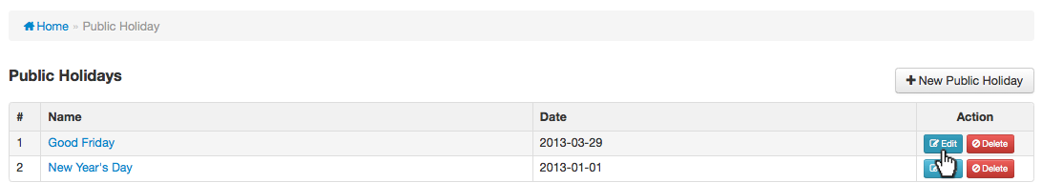

4- Edit the public holiday as you want then click button **“Save”**

### 3- Delete Public Holiday from the System

1- Log in to the system as administrator

2- Click menu **“Public Holidays”**

3- Click button **“Delete”** of the public holiday that you want to delete

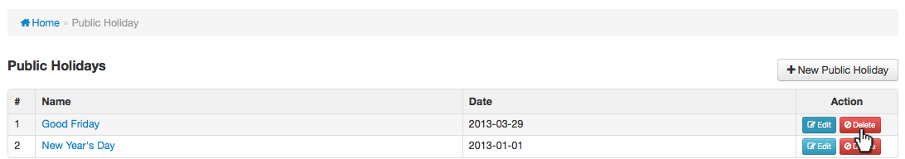

4- Click button **“OK”** to confirm delete

## F- View SMS Logs

Normally in HIV Supply Chain System, when the package deliver to the site the system will automattically sent message to that site to alert that the package has delivered. Also the site has to send back SMS to confirm received or not received the package. The system administrator can view all the messages send form system and site.

1- Log in to the system as administrator

2- Click menu **“SMS Logs”**



There are 4 different tabs of SMS logs:

* **Requisition Deadline:** is the system alert message sent to the site which is not yet submit the requisition.
* **Package shipped:** is the system alert message sent to the site to inform that the package is in shipping progress to that site.
* **Alert shipment received?:** is the system alert message sent to the site incase of there is no receiving reply from the site.
* **SMS from site:** is the SMS from the site to confirm that they received package or not.

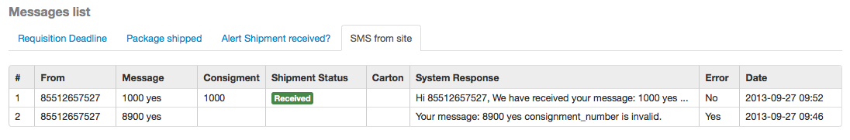

# **VII- Site User in HIV Supply Chain System**

In HIV Supply Chain System, we have designed base on the user level. Log in to HIV Supply Chain System, site user can:

* download requisition report template for filling in the order
* report new requisition to order new commodities and kits

## A- Download Requisition Report Template

In order to do the drug or/and kits commodities order, the user at the site have to download the requisition report template and fill in the order before uploading to the system to order.

1- Log in to the system as the site user

2- Click button **“Download Requisition Report Template”**

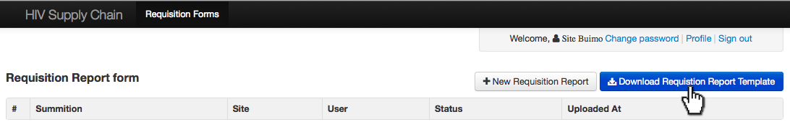

3- Save the template to your local computer.

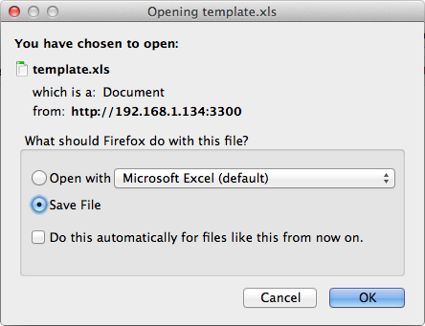

## B- Fill in Requisition Report to order commodities

In order to order the drug or kits commodities, the site have to fill in the commodities in the requisition form that have downloaded from the system.

1- Open the requisition form you have lownloaded from the system. There are two different sheets of the requisition form. The sheet “**ARVs requsition forms**” and “**TestRequisitionForm**”.

2- Click on sheet “**ARVs requsition forms**” and fill in the drug commodities that you would like to order.

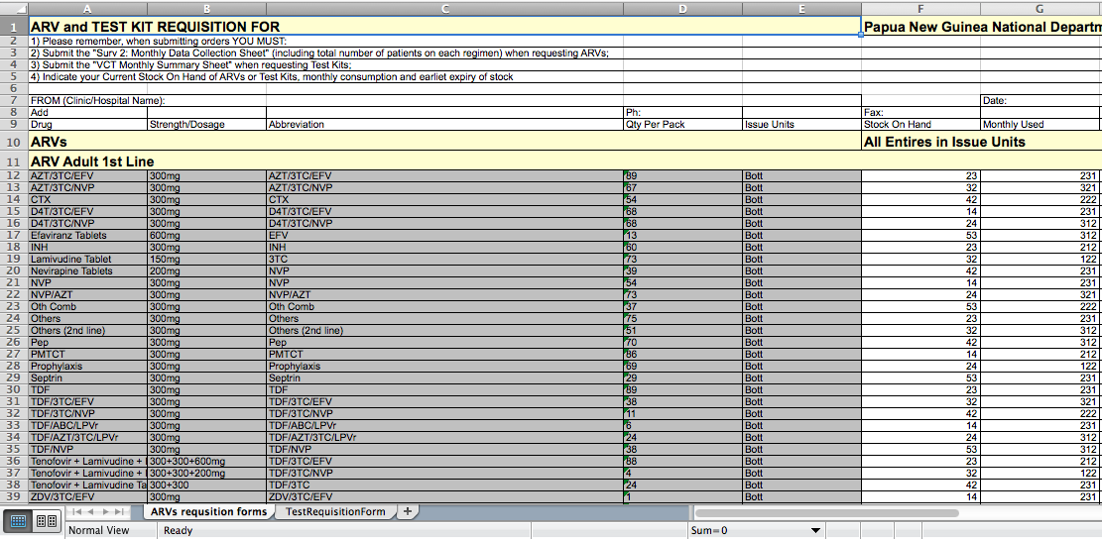

3- Click on sheet “**TestRequisitionForm**” and fill in the kit commodities that you would like to order.

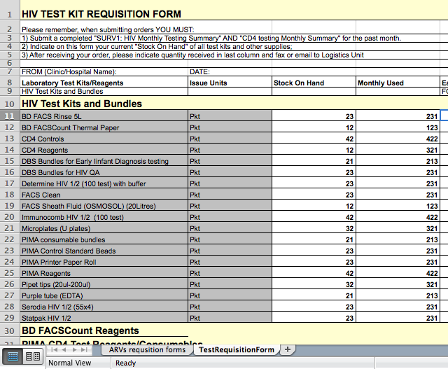

4- Save the requisition excel file

## C- Upload Requisition Report to order the commodities

After fill in the requisition form, sit user have to upload this form to the system and this order will automatically appear to the system reviewer.

1- Log in to the system as the site user

2- Click button **“New Requisition Report”**

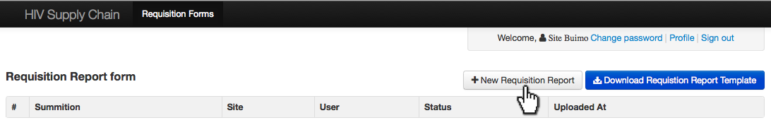

3- Click button **“Browse”**

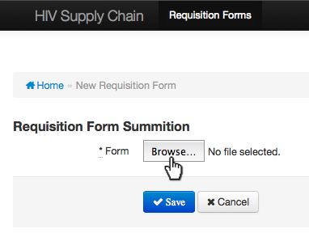

4- Choose the requisition form file that you have fill the commodities order

5- Click button **“Save”** to upload the order

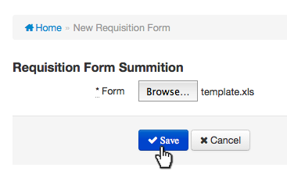

Now the site user can see their pre-order as the screenshot below

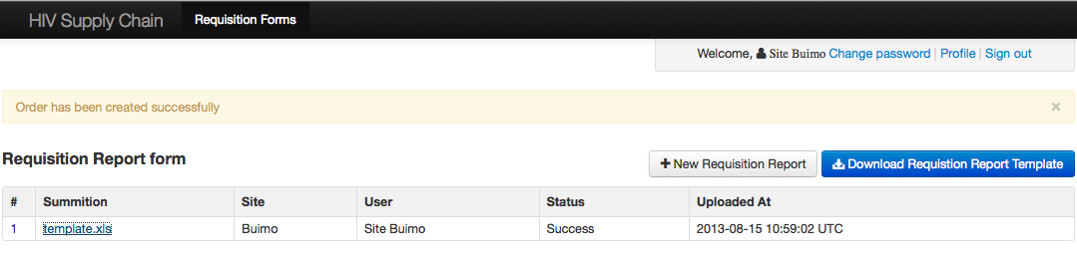

# **VIII- Data Entry User in HIV Supply Chain System**

In HIV Supply Chain System, when there is order from the site, the role of data entry user is to review these orders before submitting these orders to reviewer, make order, revise the order when there is any feedback from reviewer and entry the data of SURV1 and SURV2.

## A- Entering SURV form data

SURV form in HIV Supply Chain System is the number patients who receive each service of each site.

1. Log in to the system as data entry user
2. Click on menu **“SURV”**

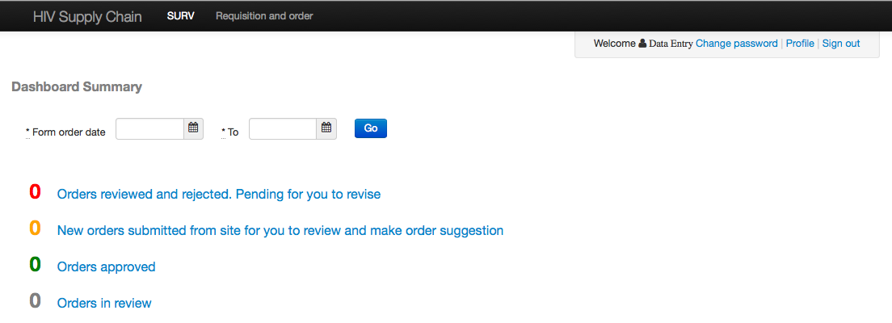

1. Click on tab **“Surv1”** or **“Surv2”**
2. Click on **“New Surv1”** button if you choose surv1 tab or **“New Surv2”** button if you choose surv2 tab.

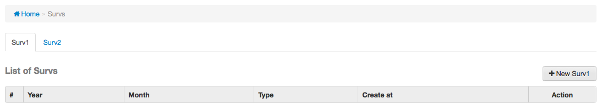

*This screenshot shows that we’re going to enter data by using form surv1.*

1. Select the month and year for the data that you’re going to input. You also copy from the excel file and paste to this online surv form also.

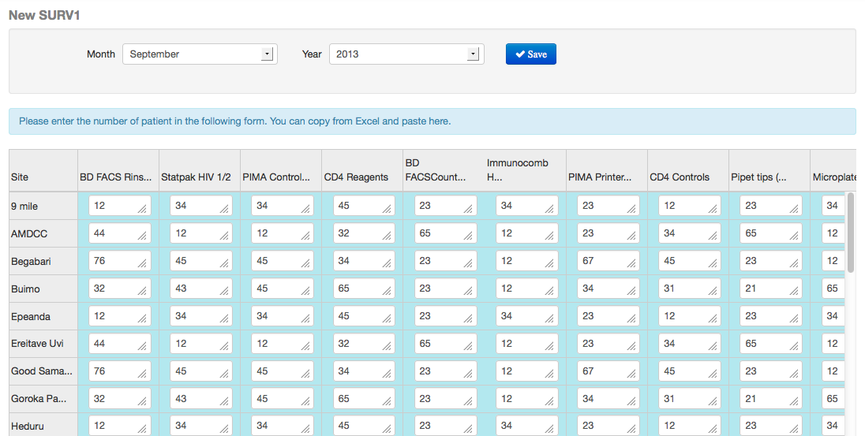

*This screenshot is the data of surv1 for September 2013.*

1. Click **“Save”** button

## B- Edit Data in SURV form

1. Log in to the system as data entry user
2. Click on menu **“SURV”**
3. Click on tab **“Surv1”** or **“Surv2”** that you want to edit data
4. Click **“Edit”** button of the surv form data that you want to edit

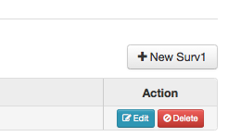

1. Edit the data as you want and click **“Save”** button

## C- Delete SURV form’s data

1. Log in to the system as data entry user
2. Click on menu **“SURV”**
3. Click on tab **“Surv1”** or **“Surv2”** that you want to delete
4. Click **“Delete”** button of the surv form data that you want to delete



1. Click **“OK”** button to confirm delete

## D- Make Requisition Order

1. Log in to the system as data entry user
2. Click on menu **“Requisition and order”**
3. Click **“New Order”** button
4. Click **“Drugs”** tab to make drug requisition order and/or **“Kits”** tab to make kit requisition order.
5. Fill in the required information as bellow:

* **Site:** click on drop down list and choose the site that you want to make order.
* **Order Create:** set the date of creating order.
* **Order Received:** set the date of receiving order.
* **Stock on hand:** fill in the remain stock for each commodity.
* **Monthly use:** fill in the number of monthly use for each commodity.
* **Quantity suggested:** fill in the suggested number for each commodity.

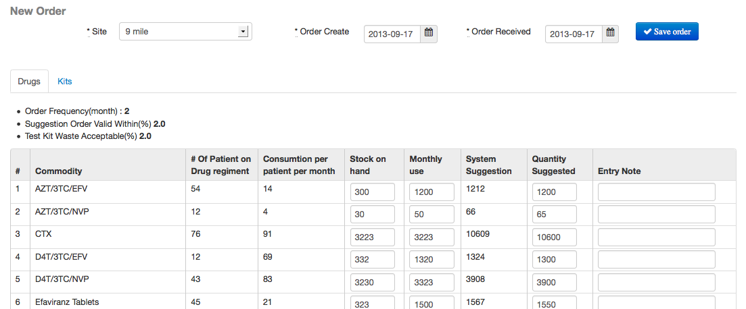

*This screenshot shows the drug order for site 9 mile.*

1. Click **“Save order”** button to make order.

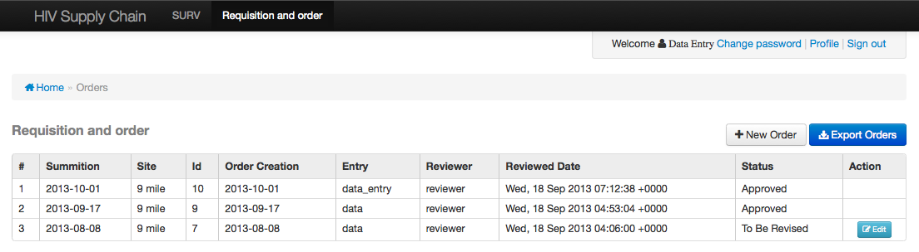

*This screenshot is showing the list of orders. You can export this order list as Excel csv by click* ***“Export Orders”*** *button.*

## E- Edit Requisition Order

1. Log in to the system as data entry user
2. Click on menu **“Requisition and order”**
3. Click **“Drugs”** tab to edit drug requisition order or **“Kits”** tab to edit kit requisition order.
4. Click **“Edit”** button of the requisition order that you want to edit.

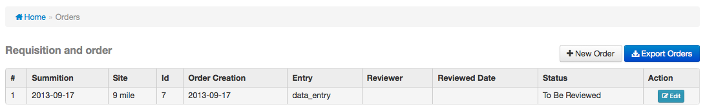

1. Edit the requisition order and click **“Save order”**

# **IX- Reviewer User in HIV Supply Chain System**

The role of reviewer in HIV Supply Chain System is to review the order from each site and submit the order to shipment or reject the order and submit back to data entry for correction. In the first log in page as reviewer, it shows the dashboard summarize the number of orders pending for review and number of order reviewed and rejected.

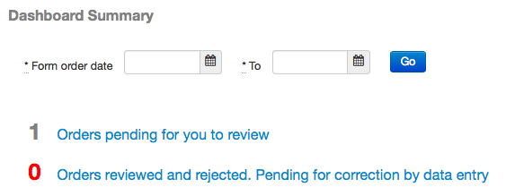

*This screenshot shows that there is one order pending for reviewer to review and zero order reviewed and rejected. Reviewer also can filter the order by setting the date range.*

1. Click **“Requisition and order”** menu. The list of order will show with the status:

* **To Be Reviewed:** is the order that just submit from data entry and ready for reviewer to review.
* **To Be Revised:** is the order that already reviewed by reviewer and there are some commodity not approved and need correction from data entry again.
* **Approved:** is the order that approved and already submit to shipment for packaging and ship to the site.

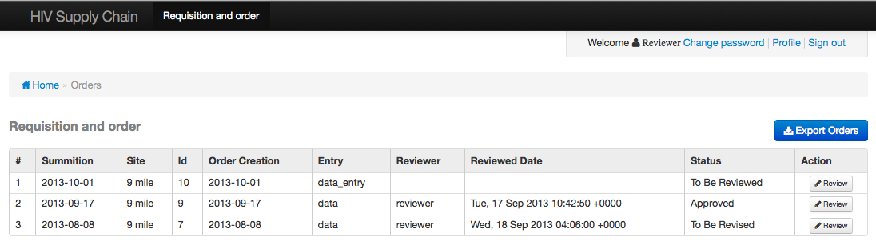

1. Click **“Review”** button of the order that you want to review.

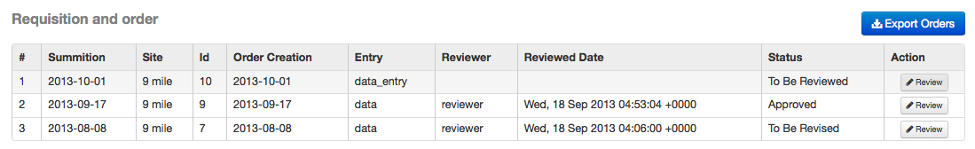

*This screenshot shows that we want to review the first order.*

1. Click on green button () of each commodity to accept the order or click on red button () to reject.

The system will automatically submit to shipment or submit back to data entry if there is any commodity rejected.

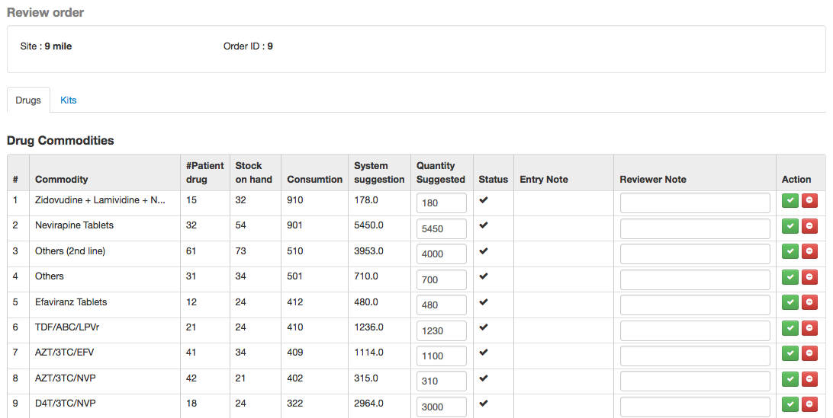

*This screenshot shows that all the commodities were approved and ready to ship to site 9 mile.*

# **X- AMS User in HIV Supply Chain System**

It’s time for shipping the commodity to the site after reviewing from the reviewer. As the AMS user, you can create shipment; mark the shipment as lost, received or partially received. Below is the first log in screen as AMS user.

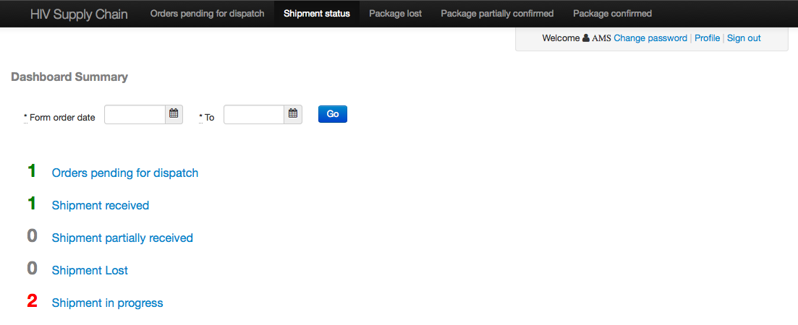

*This screenshot shows that there is 1 order is pending for dispatching, 1 shipment received, 0 shipment partially received, 0 shipment lost and 2 shipments in progress. AMS user also can also filter it by date range.*

## A- Create New Shipment

1. Log in to the system as AMS user
2. Click **“Orders pending for dispatch”** menu



1. Click on drop down list and choose the site
2. Fill in the quantity dispatch of each commodity.
3. Check the commodity that you want to include into one package.

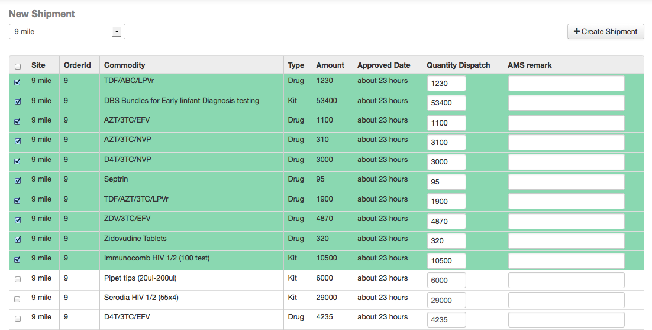

*This screenshot shows that the first 10 commodities will be packed in one package.*

1. Click **“Create Shipment”** button
2. Set the shipment date, consignment number (it must be unique), cost and carton (the number of carton in package).

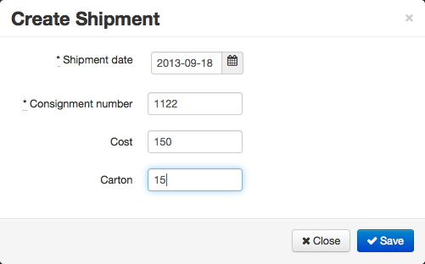

*This screenshot shows that the shipment date is 18 September 2013 and consignment number is 1122, cost is 150 and there are 15 cartons in package.*

1. Click **“Save”** button. The system will automatically sent SMS to that site and the shipping status will be marked as in progress. The selected commodities will also not exist in the list.

## B- Updating Shipment Status

When the shipment packages were shipped to the sites, normally the people at the site will confirm back by SMS if the package received or not or received only some cartons. In HIV Supply Chain System, when receiving confirm SMS from the site, the system automatically update the status as received, lost or partially received.

The AMS user also can do manually update status of the shipment package. Below is the instruction how to manually update status.

1. Log in to the system as AMS user
2. Click **“Shipment status”** menu

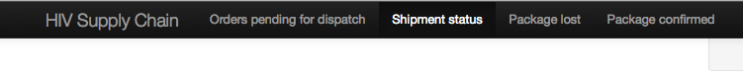

1. Check on the shipment package that you want to mark
2. Click on drop down list at the top-right of the list and choose:

* **Mark as lost:** if the site is not received the package.
* **Mark as received:** if the site has received package.
* **Mark as partially received:** if the site has received only some cartons in package.

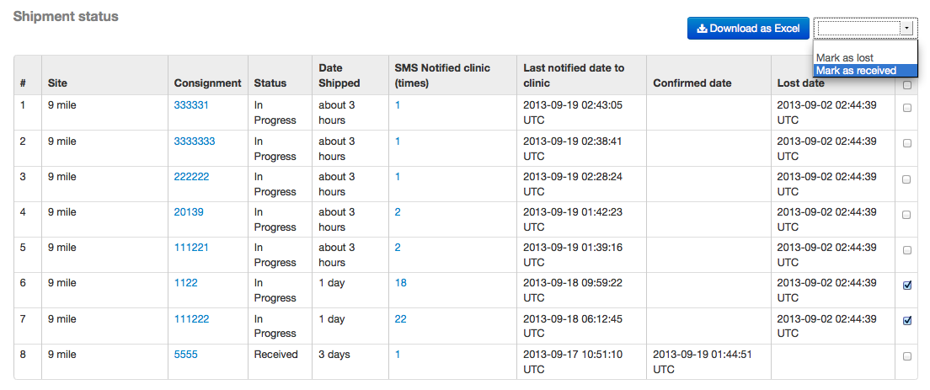

*This screenshot shows that the shipment package with consignment number “111222” and “1122” which is ship to site “9 mile” will be marked as received.*

AMS user also can download the shipment list as Excel csv by clicking **“Download as Excel”**.   
Clicking on menu:

* **Package lost** to view the list of lost package only.
* **Package partially confirmed** to view the list of package has received some carton only.
* **Package confirmed** to view the list to of package has received.

# **XI- SMS Confirm from the Site**

In order to change the shipment status as received, lost or partially received, HIV Supply Chain System needs the confirm message from the site. Below is the format message for site to send to the system.

**Consignment_Number Status Number_of_carton**

* **Consignment_Number**: is the shipment consignment number. The sites receive this number when the package shipped and also this number is on the package.
* **Status:** can be received, lost or partially received.
  + If **Received** they just type: **R** or **Y** or **Yes** or **Received**.
  + If **Partially Received** they just type: **P** or **Partial**.
  + If **Lost** they just type: **L** or **N** or **No** or **Not** or **Lost**.

User can type in upper or lower case, and it works well.

* **Number_of_carton**: type the number of carton received, but it’s optional.

*Example:*

- **1122 R 15** (mean that the consignment number 1122 is received with 15 carton)

- **1122 No** (mean that the consignment number 1122 is lost)

- **1122 P** (mean that the consignment number 1122 is partially received)